

**Bachelor of Engineering (Honours) in Computer & Electronic Engineering**

**Final Year Project: Music Host Interface**

**Weekly Project Logs**

**Student Name: Thomas Flynn**

**Student ID: G00291875**

**Project Supervisor: Brian O'Shea**



**Computer & Electronic Engineering**

**Final Year Project "Music Host Interface"**

**Sprint 1: Week 1 Log**

**Thomas Flynn**

**Project Supervisor: Brian O'Shea**

**18/10/15**

**Update:**

This year we have been thought the importance of project management in the module "The Professional engineer". I'm applying what I learn in this module to my own project management system.

For my own Project management I will be using Trello.com

**Trello** uses the [kanban](https://en.wikipedia.org/wiki/Kanban) paradigm for managing projects, originally popularized by [Toyota](https://en.wikipedia.org/wiki/Toyota) in the 1980s for supply chain management. Projects are represented by ***boards***, which contain ***lists*** (corresponding to task lists). **Lists** contain ***cards*** (corresponding to **tasks**). **Cards** are supposed to progress from one **list** to the next (via drag-and-drop), for instance mirroring the flow of a feature from idea to implementation.

In the figure below you can see my current project board setup.

**Lists**

**Inbox:** Whenever an idea or new task pops into my head, it goes in here.

**Later:** Tasks to be completed at a later date

**Doing:** Current task to be completed.

**Sprint X:** Tasks to be completed in this sprint.

**Done Sprint X:** Tasks I completed in this sprint.

**Labels:**

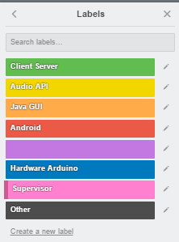

Each task has a colour label attached to it to help differentiate between aspects of the project.

**Trello Board:**

